Lowick Parish Council
Ann Gold
Parish Clerk
Barmoor South Moor
Lowick
TD15 2QF
tel: 01289 388205

Press Release
21.1.16

LOWICK PLANS FOR THE FUTURE
COUNCIL SEEKS VOLUNTEERS TO HELP DRAW UP ITS DEVELOPMENT PLAN
The village of Lowick has decided to accept the offer of “more power to the people” and join the expanding number of councils who have decided to write their own Neighbourhood Plan. The process, which started in the autumn, is about to enter the research and consultation phase. This involves reviewing the existing buildings in the village, and consulting the community on the developments of the future.

John Huddart, the Chair of Lowick Parish Council, says: “We are a small community, but we believe we should have a say in the development. Planning decisions are usually taken without any reference to local feelings, and not even the County Planning Committee has much say these days. The only way for people to have a voice is by writing a Neighbourhood Plan that the planners have to take account of.”
The village has already applied to the county council and has been given the go-ahead to start work. It is now seeking to take the next step – the appointment of a local steering group that will oversee the work which needs to be done.

John adds: “We are employing a consultant who will guide us through, providing the advice lay people need about planning laws and architectural and building principles. We need a steering group that will oversee the process and add local views.”

“We are looking to recruit people who have local connections to help – either as members of the steering group, or who have time to help write the plan. We have a website – www.lowickneighbourhood.wordpress.com – which has the details, and a form to sign up there – or you can get in touch with the Parish Council, or me directly.”

John Daniels, chair of the Lowick Heritage Group adds: “We have a vigorous and lively membership and we are keen to see the village develop a proactive approach to conserving and educating about our heritage and buildings. We hope the Plan will help ensure that Lowick’s past is as important in planning decisions as its future.”

Conserving the heritage of the Parish while encouraging development that will ensure it continues to be a prosperous community, where people of all ages can live and work, are the two principles the group hopes to promote. It is expected to take about 2 years to prepare the plan, which will be submitted to community consultation at every stage.

“It is vital we involve everyone in the process – this is as much about bringing the community together, as writing a planning document. If you live here, work here, own a business here, or property, you are entitled to have a voice. We hope that you will join is in doing the work – or at the very least let us know your ideas,” adds John.

“At the end of the consultation a community vote is taken, and if a majority approves the proposals become the village Neighbourhood Plan. If you wish to be actively involved, you should log onto the website and sign up!”

More details may be had from the website, or from John Huddart at lowickparish@outlook.com.

Image
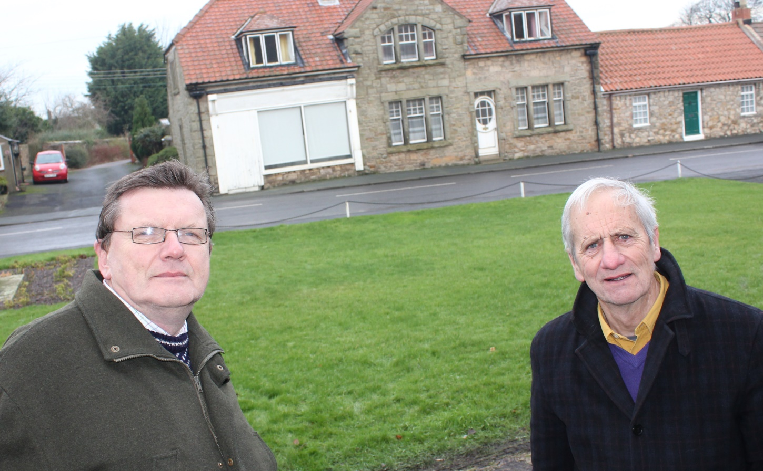
John Huddart and John Daniels who will be working to produce Lowick’s Neighbourhood plan over the coming months.

