Topic Paper 1 Settlement Boundaries

Lowick Neighbourhood Plan

Methodology and assessment of settlement boundaries in proposed the Lowick Neighbourhood Plan

June 2019

Contents:

1.0 Introduction

2.0 Lowick Settlement Approaches

Western boundary Northern boundary Eastern Boundary Southern Boundary

3.0 Conclusions

Introduction
  - Lowick did not have a settlement boundary identified in the Berwick-upon-Tweed Local Plan (April 1999). The extract from the Local Plan map (below) shows the allocations for housing in Lowick. S22 (Site 40) has been mostly completed, and S22 (Site 39) has consent and is being implemented.
  - Northumberland County Council have identified settlement boundaries for a number of settlements throughout the County in the Northumberland Local Plan (adopted March 2022). However, Lowick was not given a settlement boundary, due to the fact that the Lowick Neighbourhood Plan was being prepared, with a settlement boundary proposed. The matter of determining a settlement boundary for Lowick has therefore been left to the qualifying body (Lowick Parish Council) to determine.
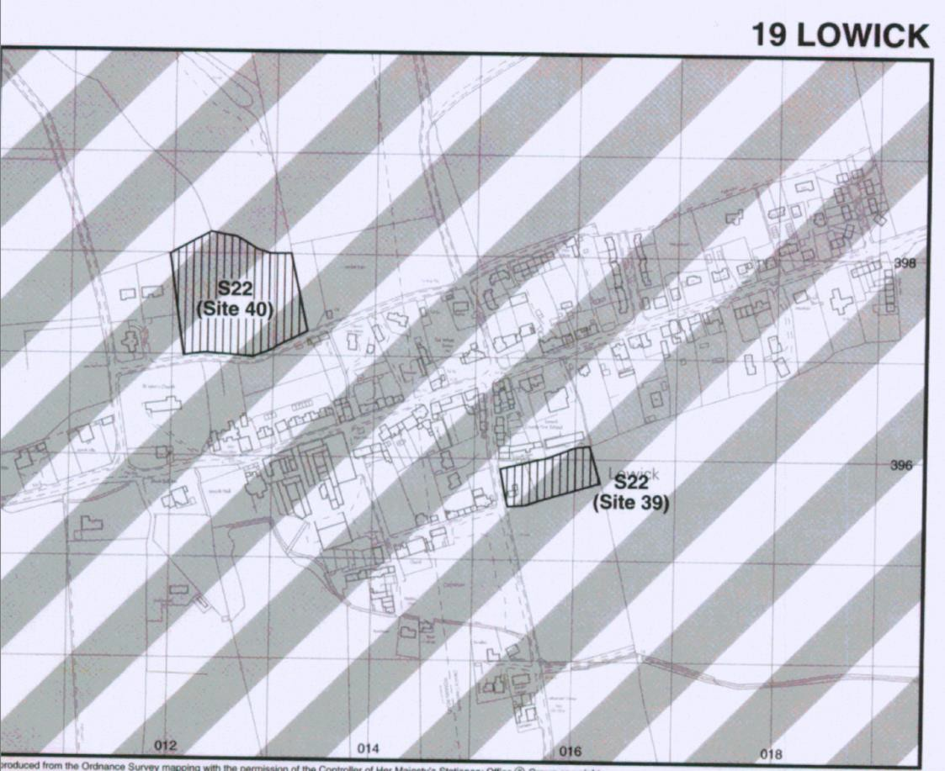
Figure 1: Extract from Berwick upon Tweed Local Plan Proposals Map (1999)

  - This paper should be read alongside the ‘Settlement Boundary Methodology’ report (March 2018 (updated in January 2020). Jointly, these reports present the detail and reasoning behind the decision to define a settlement boundary for Lowick as shown on the proposed inset Policies Map for the Neighbourhood Plan.
  - There has been extensive consultation with residents and landowners on various different scenarios with regard to the settlement boundary. The statutory consultation will take place at the Regulation 14 stage, and following that consultation, the settlement boundary may be amended.

  - The boundary has been defined within the context of a requirement for the Neighbourhood Plan to deliver sustainable development in the Plan area. As such, it is based on the need to ensure there is sufficient housing land available within the settlement boundary of Lowick to accommodate the required level housing growth over the plan period up to 2036.
  - Policy HOU3 (Housing requirements for neighbourhood plan areas) in the Northumberland Local Plan contains detail about housing delivery targets for each designated Neighbourhood area in Northumberland County. The Lowick Neighbourhood Area is expected to deliver 25 houses over the Plan period.
  - More detail about housing numbers and housing issues is contained in the background housing report. This report explains that there are 39 dwellings with planning approval in Lowick which is well in excess of the housing requirement identified by Northumberland County Council.
  - The settlement boundary has therefore been drawn relatively tightly around the village of Lowick, incorporating existing built development and proposed development (with planning permission) within the settlement. The methodology (referred to earlier) has been used to define exact boundaries and this report should be read alongside the methodology, which was agreed by the Qualifying Body.

Lowick

  - The map below shows the proposed settlement boundary for Lowick in the emerging Lowick Neighbourhood Plan and identifies locations from which photographs in the text to follow have been taken.
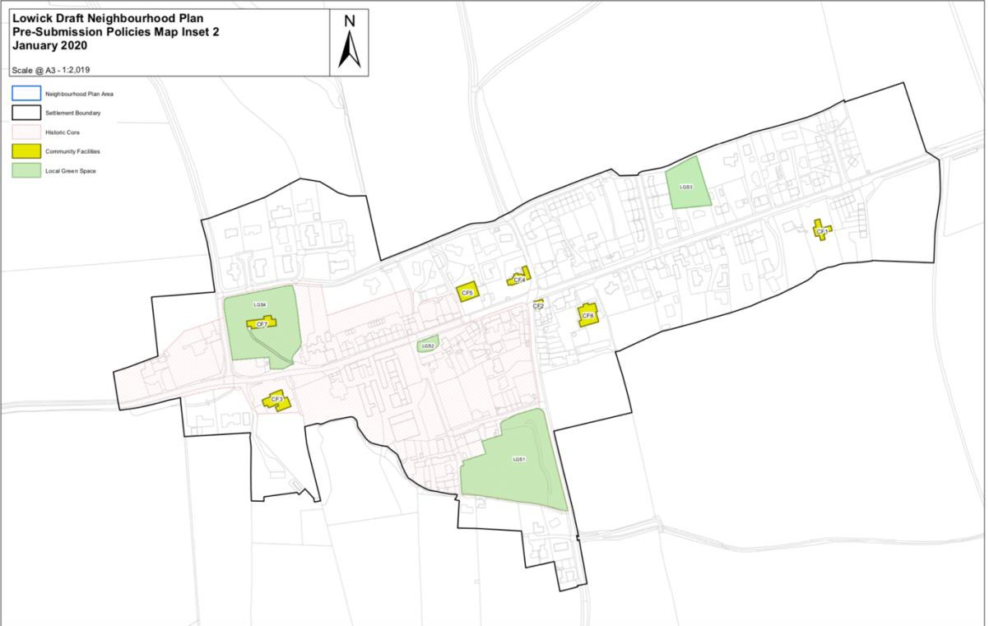
Photo 2
Planning permission
granted for dwellings
Photo 5
Site with extant planning permission
Photo 3
Photo 1
Land with planning permission for house
Photo 4
Planning permission granted for 24 dwellings on these two sites

  - Western boundary: The western boundary follows the line of development which has been characteristic of Lowick for hundreds of years. It includes land which has planning permission for a house (shown on plan opposite) and follows the boundaries of extant permissions and existing development.
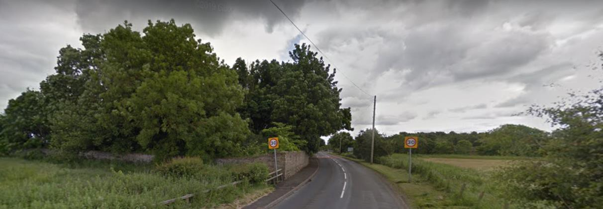
Photo 1: Taken looking into the village from western approach (B6353).

  - The photo above shows the entrance to Lowick village from the west. To the left is the boundary wall of the first property; a rural feel dominates the approach which leads directly into the historic part of the village.

  - Northern Boundary: The northern boundary follows curtilages of existing modern housing and includes boundaries of approved development sites. Beyond these areas of housing are open fields with expansive views towards the coast.
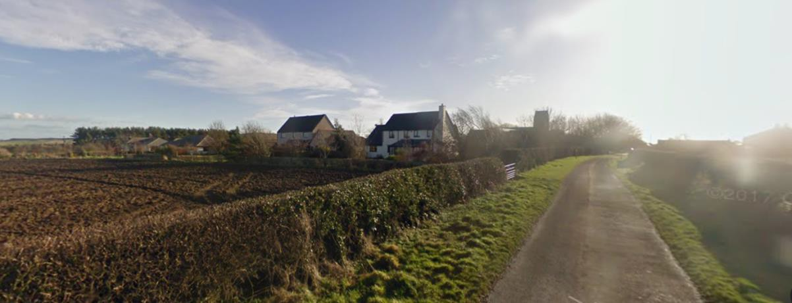
Photo 2: Approach into the village from the north

  - Dryburn Road is popular with residents and particularly valued for its biodiversity (see Topic Paper 3). This provides another approach into the village from the north (below). There is a clearly defined boundary between existing (modern) housing, and the open countryside, which will be maintained along already defined garden boundaries.

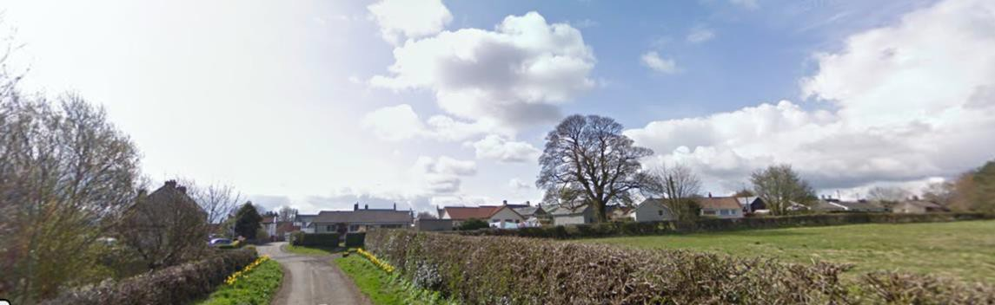
Photo 3: Approach from the north (Dryburn Road)

  - Eastern boundary: The eastern approach to the village (from the A1) is shown in the photograph below. Planning permission has been granted for 24 houses in the foreground (not yet implemented). This land is included in the settlement boundary
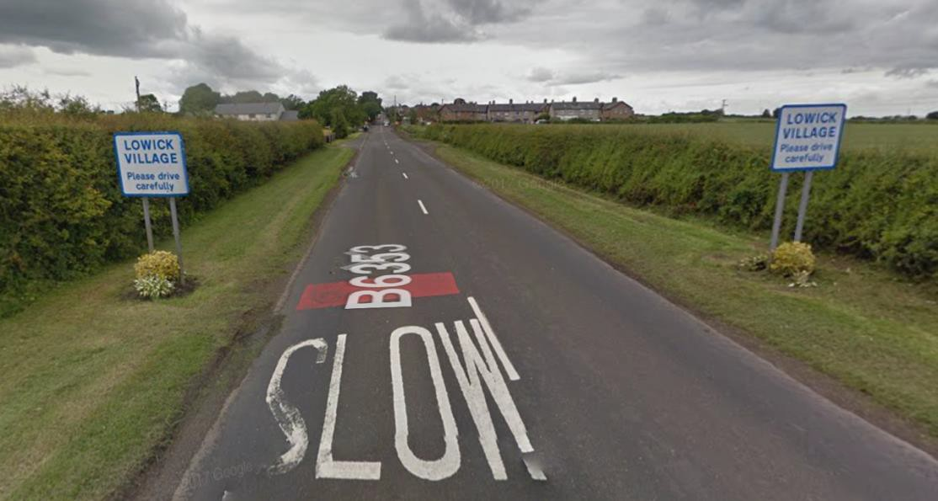
Photo 4: Approach to Lowick from the east

  - Southern boundary: The southern approach is sensitive, with the Common and much of the historic core of the village coinciding with the settlement boundary (left side of photo). Planning permission has been granted for development in this part of the village on land occupied by the barn to the right, and that land is also included in the settlement boundary.

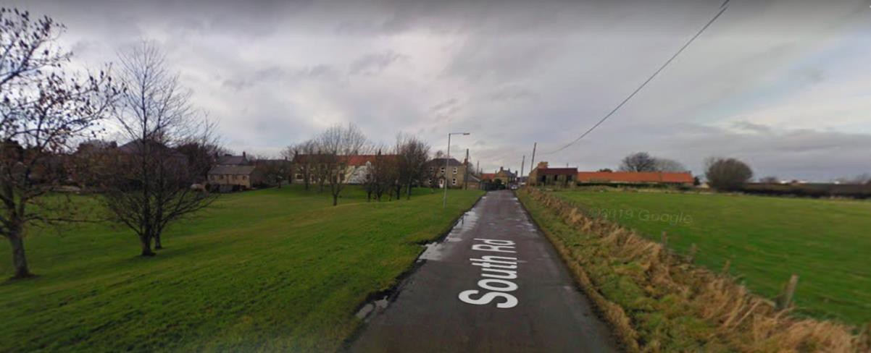
Photo 5: Approach from the South with 'The Common' on the left

Conclusions

  - It is considered that the settlement boundary identified constitutes the most appropriate approach to managing development in the settlement of Lowick. The tightly drawn boundaries allow for housing delivery, both through windfall development and through inclusion of sites with planning permission for housing. Other policies in the neighbourhood plan seek to ensure that infill development contributes to the special character and sense of place in Lowick.
  - Given the fact that the Neighbourhood Area has been given a target of 25 new houses over the Plan period, the approach taken has been to draw tight boundaries around existing residential development including recently approved development, but to restrict any further development for housing beyond the settlement boundaries identified except for rural exception sites.
  - Wherever possible, natural boundaries have been used, such as boundaries of gardens, walls, fences, tree and hedge lines.

