Topic Paper 3 Local Green Spaces
Lowick Neighbourhood Plan

Assessment of Local Green Spaces in Lowick Parish against criteria set out in paragraph 102 of the NPPF.

Originally drafted Sept 2019
Updated April 2022
  - Introduction
  - Local Green Spaces can be defined through Neighbourhood Plans. These spaces must meet a set of criteria which are set out in the NPPF (paragraph 102).
  - The purpose of this background paper is to provide supporting information/evidence regarding the value of green spaces in the Parish of Lowick, in order to support their designation as Local Green Spaces through the Lowick Neighbourhood Plan.
  - A number of potential local green spaces were discounted, (these are summarised at the end of the paper). The remaining green spaces are numbered 1 – 5.

  - Local Green Spaces
  - This section identifies each of the proposed Local Green Spaces identified in the emerging Lowick Neighbourhood Plan,

LGS1: The Common
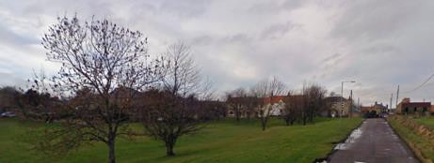

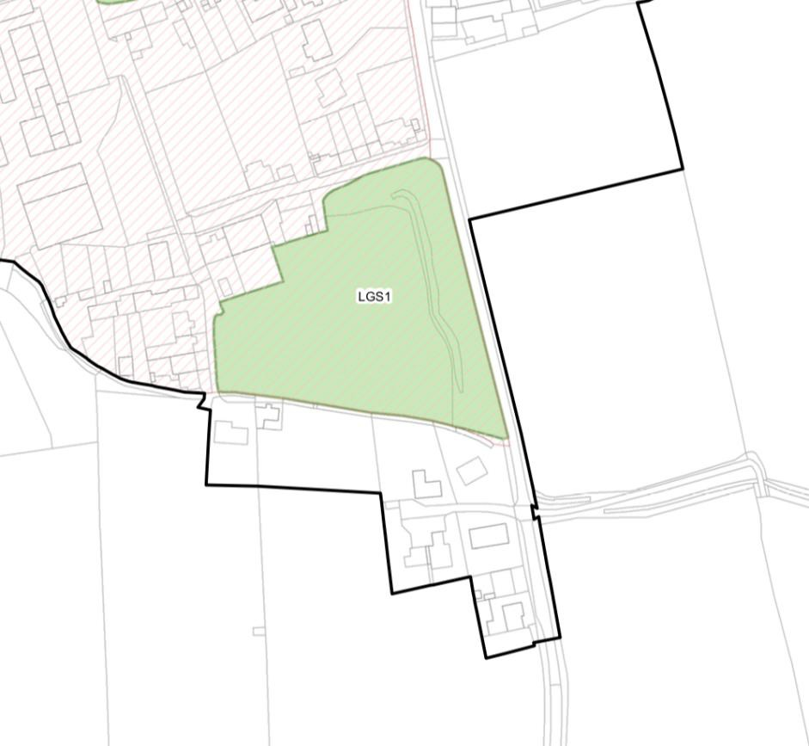
  - The Common has been an integral part of Lowick village for centuries. It can be seen on old maps and has been incorporated into the Historic Core of the village. It is owned and managed by the Parish Council. [check]> It is highly valued by the local community as an integral ‘green’ area in the village.
    - Reasonably close proximity to the community it serves
    - Demonstrably special to the local community
    - Local significance for recreational value
    - Local significance for historic value, having been associated with the village for centuries
    - Local in character and not an extensive tract of land

LGS2: Lowick War Memorial
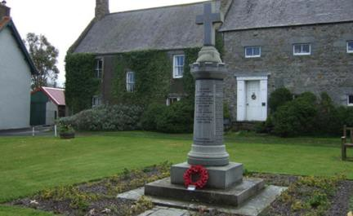
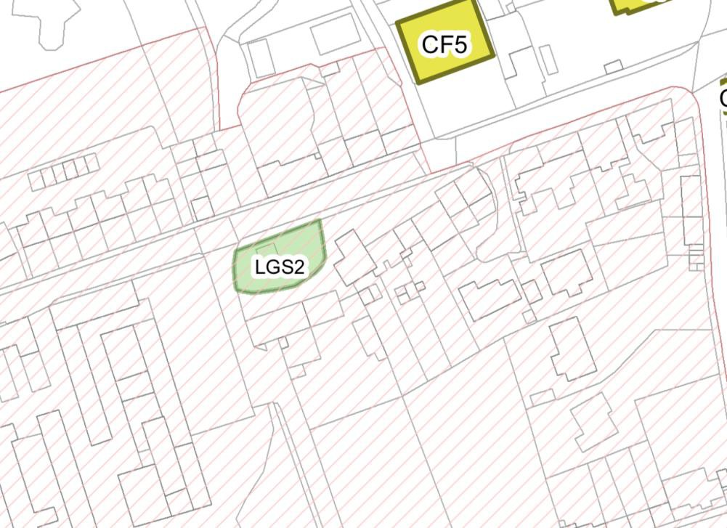
  - Lowick War Memorial and the gardens around it is located in the centre of the village. It is a small, but well-used space, and important to the historic context and openness of this part of the village.
    - Reasonably close proximity to the community it serves
    - Demonstrably special to the local community
    - Local significance for historic value as a war memorial and place of reflection
    - Local in character and not an extensive tract of land

LGS3: Lowick Play Park
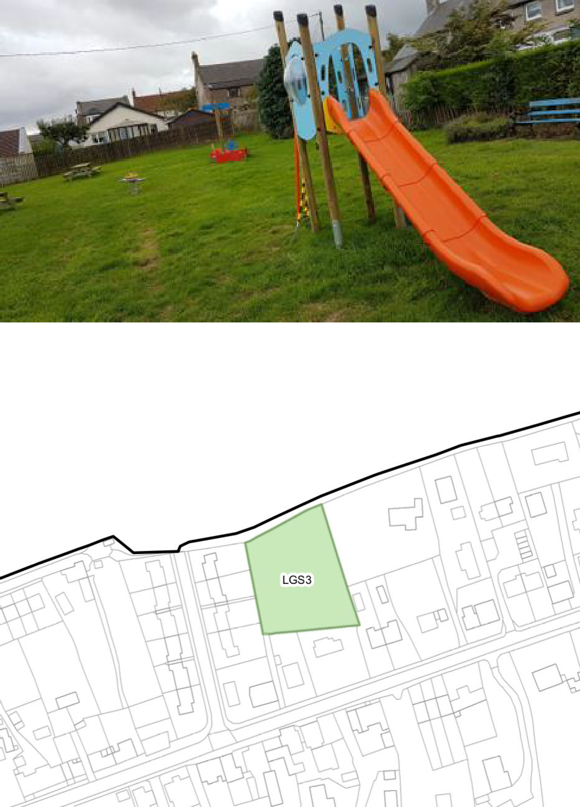
  - This is the only play park in the village and is used by younger children. It is located within existing housing development, and is owned and managed by the Parish Council [check]
    - Reasonably close proximity to the community it serves
    - Demonstrably special to the local community
    - Local significance for recreational value
    - Local in character and not an extensive tract of land

LGS4: Cemetery
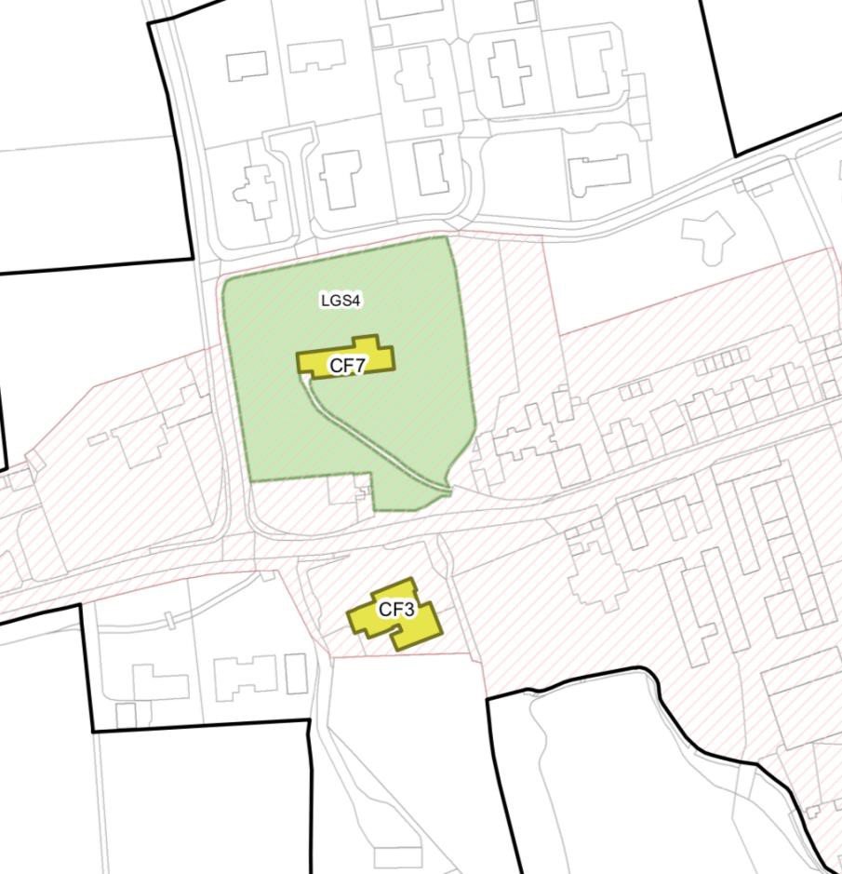
  - The cemetery surrounds the St. John the Baptist Church which is identified as a community facility in the Plan. This green space is highly valued by the community.
    - Reasonably close proximity to the community it serves
    - Demonstrably special to the local community
    - Local in character and not an extensive tract of land

LGS5: Holburn Village Green
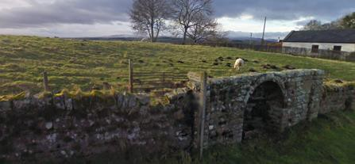
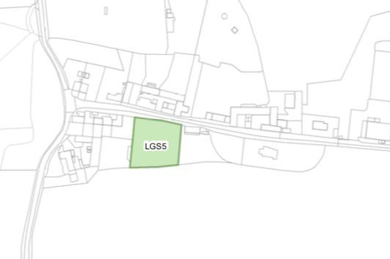
  - The village green in Holburn has been an integral part of the settlement for centuries. It plays an important role in the setting of the village, and has public access.
    - Reasonably close proximity to the community it serves
    - Demonstrably special to the local community
    - Local significance for recreational value
    - Local in character and not an extensive tract of land

  - Discounted Green Spaces
  - Three other spaces were identified: The Community Orchard, the Football Field, and the woodland area behind the Black Bull.
  - The community orchard was discounted following an objection from the owner to its

inclusion in the Neighbourhood Plan as a Local Green Space. Although the Community Orchard does fulfil all criteria for a Local Green Space it was considered inappropriate to include it against the landowner’s wishes.
  - Similarly, the football field, although highly valued by the local community, is not to be
included in accordance with the landowner’s wishes.
  - The land to the rear of the Black Bull is an area of woodland which is valued by the community for its biodiversity value. However, there is no public access, and it is not considered that it fully meets the criteria for inclusion as a local green space.

